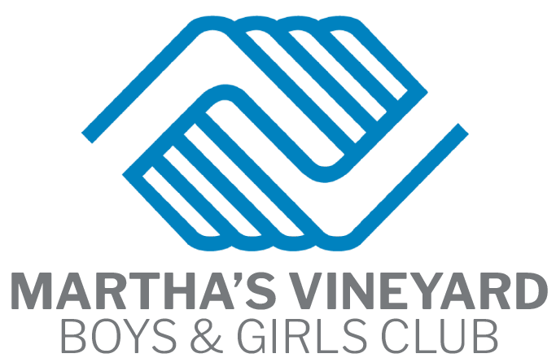

Executive Director
Position Summary: An exciting opportunity to lead the Martha’s Vineyard Boys & Girls Club is open and we are looking for our next Executive Director to make a positive impact on kids’ lives. We are looking for candidates that will lead the overall planning and operation of the organization while providing leadership, direction and support to the Board of Directors.
Boys & Girls Clubs mission is to enable all young people, to reach their full potential as productive, caring, responsible citizens. You will be responsible for bringing this mission to life in this community, as you work to ensure that the kids and teens in your care achieve great futures by providing a safe and fun space, an engaging Club Experience, and managing caring professionals to guide them along the way.
JOB RESPONSIBILITIES:
Leadership
Ensure the effective operation and delivery of programs within the Club and community: Support the organization’s mission and principles;
Maintain an environment that facilitates the achievement of youth development outcomes and uses outcome measures to demonstrate effectiveness;
Establish and monitor adherence to policies and procedures; and implement programs, services and activities that support youth development outcomes

Strategic Planning
Ensure and oversee a strategic planning process that results in the development and implementation of a quality strategic plan.
Identify and evaluate opportunities for improvement and implement plans to improve using KPIs and data analytics.
Guides, supports and serves the Board of Directors in establishing goals and developing policies, procedures, budgets and programs that fulfill the mission of the Boys & Girls Club.

Resource Development
Ensure the annual budget is funded and organization has adequate cash flow.
Oversee the develop strategic plans to generate revenue through a variety of fundraising techniques. Identify, cultivate, solicit donors. Oversee planning and implementation of special events.
Provide guidance to staff and volunteers performing resource development functions.

Resource Management
Develop, implement and monitor the Club’s annual budget.
Implement administrative and operational systems to support effective operations. Ensure productive and effective staff performance, with a focus on Club and child safety; provide guidance, feedback and opportunities for professional development

Technology
Ensure development, implementation and monitoring of plans for updating existing technology and resources
Ensure the maintenance of Club technology and information systems

Partnership Development
Develop strategic alliances with community leaders and local officials. Develop collaborative partnerships with other youth serving organizations, members, parents, families, funders and community organizations.

ADDITIONAL RESPONSIBILITIES:
May be assigned special projects periodically by the Board of Directors.
Currently the Marthas Vineyard Boys and Girls Club is pursuing the construction and development of a new facility adjacent to our current building. The new director will be at the forefront working with our Capital Campaign Committee and being out front in the community to help us navigate this project and to bring all the possibilities of such an endeavor to light.

SKILLS/KNOWLEDGE REQUIRED:
- Bachelor's degree from an accredited college or university preferred
- Minimum of 5-7 years’ experience in managing programs or operations in a non-profit agency or Boys & Girls Club with at least two years in a leadership capacity; or an equivalent combination of experience
- Thorough knowledge of: the mission, objectives, policies, programs and procedures of Boys & Girls Clubs
- Demonstrated ability to plan and implement effective operations
- Leadership skills, including negotiation, problem solving and decision making
- Strong communication skills, both oral and written
- Ability to establish and maintain effective working relationships with the Board of Directors, staff, community groups and other related agencies
- Basic knowledge of asset management including financial resources and property

Ad for Gazette, MVNPC, National, Website, Chamber

Executive Director
Organization: Martha’s Vineyard Boys & Girls Club
Location: Edgartown, MA

Position Overview
The Martha’s Vineyard Boys & Girls Club is seeking an inspiring, visionary, and community-minded leader to serve as our next Executive Director. This is an exciting opportunity to shape the future of youth development on the island, building upon our mission to enable all young people to reach their full potential as productive, caring, and responsible citizens.
The incoming Executive Director will oversee the strategic planning, financial health, and overall operations of the organization while providing dynamic leadership and support to our dedicated Board of Directors.

Key Responsibilities
- Strategic Leadership: Guide the overall planning, management, and operational execution of the Club’s programs and community initiatives.
- Mission Advancement: Bring the Boys & Girls Club mission to life by ensuring local kids and teens achieve great futures in a safe, fun, and engaging environment.
- Team Management: Lead, mentor, and empower a team of caring professionals and youth development staff.
- Board & Community Collaboration: Partner closely with the Board of Directors and island stakeholders to secure resources, champion legislative advocacy, and drive sustainable growth.

What We Are Looking For
- A Passion for Youth Development: A deeply held commitment to building safe spaces and delivering high-quality Club experiences.
- Proven Executive Leadership: Experience managing operations, budgeting, and strategic organizational growth.
- Community Connector: An exceptional communicator capable of engaging with families, board members, donors, and community leaders alike.

How to Apply
If you are ready to make a lasting, positive impact on the lives of Martha's Vineyard youth, we want to hear from you! Please submit your resume and a cover letter detailing your leadership experience and vision for the Club to jbradleysimpkins@gmail.com

The Martha’s Vineyard Boys & Girls Club is an Equal Opportunity Employer.

